Regio-selective Biomimetic Oxidation of Unactivated Alkyl C-H bonds using Iron-Complex
Santanu Pattanayak, Sandipan Jana, Kundan K. Singh and Sayam Sen Gupta*
Department of Chemical Sciences, Indian Institute of Science Education and Research Kolkata Mohanpur 741246
E-mail: sayam.sengupta@iiserkol.ac.in

Abstract
Chemoselective oxidation of alkyl C–H bonds in complex natural products under mild conditions have the power to reorient biomimetic natural product synthesis. Non-heme iron complexes bearing tetradentate N-donor ligands with cis labile sites, mimicking the active site of Rieske Dioxygenase enzymes, show great promise for chemoselective aliphatic C−H hydroxylation. However formidable hurdle that limits their widespread application include obtaining high levels of positional selectivity and expanding the substrate scope to include complex structures that contain more than a single polar functional group and/or arene/heteroaromatic ring(s). I will discuss the use of a peroxidase mimicking Fe-complex based on the bTAML macrocyclic ligand framework (Fe-bTAML) developed by us as a catalyst that perform selective oxidation of unactivated 3° and activated 2° C-H bonds with predicatable sselectivity, high stereoretention (>98%), and very low catalyst loadings (1-2 mol %) using mCPBA/NaOCl as the oxidant. The mechanism of the reaction involves the high-valent oxo-iron(V) species.
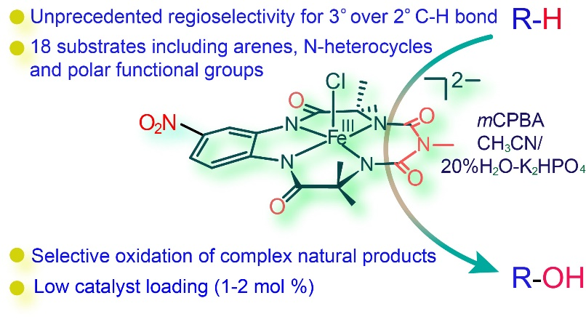

Speakers Details:

Dr. Sayam Sen Gupta,  Department of Chemical Sciences  Indian Institute of Science Education and Research Kolkata  Email: sayam.sengupta@iiserkol.ac.in | 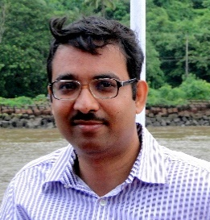
Sayam Sen Gupta did his undergraduate degree in Chemistry from University of Kolkata followed by his masters at IIT-Kanpur. He then moved to United States where he finished his doctoral degree from Carnegie Mellon University at Pittsburgh. After two post-doctoral stints in US and Germany, he joined NCL as a scientist in December 2006 where he was a Senior Scientist in the Chemical Engineering Division. He has recently moved to IISER-Kolkata in 2016 as an Associate Professor to the Department of Chemical Sciences. He is an inorganic chemist by training and works in the area of bio-inspired catalysis and materials.

